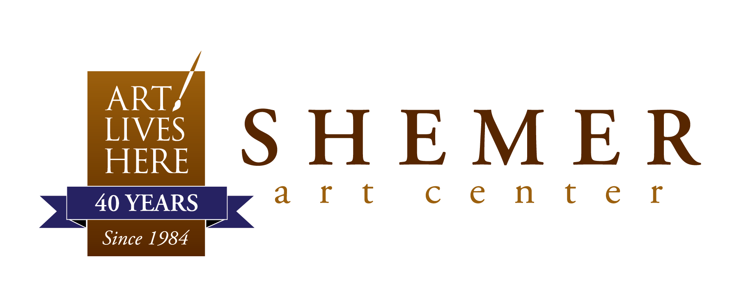

Solo & Small-Group Exhibition Proposal

The Shemer Art Center & Museum invites proposals
for solo and small-group exhibitions.

Terms and Conditions:
Submitted proposals are kept on file for 1-2 years. Proposals will be reviewed by a juror or a panel of jurors, once per year in March.
You will be notified if your work is being considered and/or accepted.

Applicants must submit the following information directly to exhibitions@shemerartcenter.org with “[Your name] Solo or Small-Group Proposal” in the subject line to be considered.

*Hard-copy application materials will not be accepted*
*Incomplete proposals will not be accepted*

- Statement of Intent
- CV/Resume
- Brief Artist Bio
- Artist Statement
- Image List (including title, media, date, size, and price)
- Up to 10 images of recent work (last 2 years) labeled with title,
media, date, size, and price in JPG format

All written materials should be submitted in either a PDF or clearly labeled
Word DOC format. Please submit images separately as JPGs. Do not put images in a PDF.

* Applicants who only submit a website or online portfolio
will not be considered. *

Application Fee: $35 for members, $45 for non-members.
Call the Shemer Art Center to pay: (602) 262-4727!

