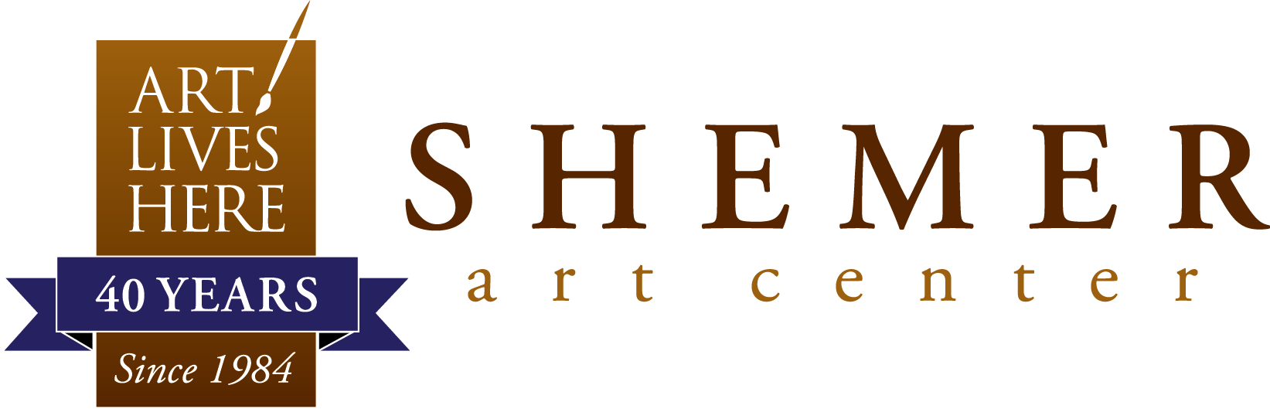

GIFT SHOP REPRESENTATION APPLICATION
The Shemer Art Center is dedicated to showcasing and supporting Arizona artists. Two of the ways we do that is through our exhibitions and gift shop.

The gift shop at the Shemer Art Center showcases original works of art created by over 60 artists from all across Arizona. Visitors will enjoy a broad selection of fine and functional art, including everything from greeting cards, jewelry, silk scarves and wall hangings, to paintings, photography, ceramic sculptures, and blown/fused glass objects. For those seeking either a small hostess/holiday gift or a decorative work of art for their home, the gift shop at the Shemer Art Center is an affordable and easily accessible treasure trove, just waiting to be explored!

If you are an Arizona artist and are interested in being represented in our gift shop, please complete this form, sign and date the back and email it to giftshop@shemerartcenter.org along with the following:

- A CV/Resume or artist statement/biography
- A PDF (or Drop Box) presentation of your works with title, media, size, price list
- A list of retail locations where your work is currently for sale in the metro Phoenix area

Note: Images must be in focus and accurately represent the items intended for sale.
Name: _______________________________________________________________
Address: _____________________________________________________________
City: ________________________________ State: _____ Zip: _______________
Phone: _______________________________________________________________
Email: _______________________________________________________________
Date Submitted: _______________________________________________________
___________________________________________________________________________________
5005 E Camelback Rd., Phoenix, AZ 85018 | shemerartcenter.org | info@shemerartcenter.org

Gift Shop Representation Terms and Conditions:
- Annual Membership to the Shemer Art Center is required for all Gift Shop Artists. Current membership levels begin at $50 for Individuals / Artists.
- All artwork must be the original work of the artist.
- The minimum price point for all work displayed in the gift shop is $25. There are some exemptions, such as greeting cards and other select items.
- All artwork must be priced the same as other retailers displaying your work in the metro Phoenix area.
- Artwork cannot contain any labels, tags or markings with personal emails, websites or phone numbers. The gift shop policy is that all sales are handled and coordinated through the Shemer.
- All artist work will be displayed for six months. Following this six-month period, all unsold artwork will be reviewed to determine if consignment of unsold work should be extended or returned to the artist.
- Shemer reserves the right to rearrange displays, remove items from the display, or request items be picked up by the artist.
- Returned works must be collected within 30 days of the agreed pick-up request. All works not picked up will be considered a donation to the Shemer Art Center.
- The Shemer Art Center retains a 30% commission on all sold artwork.
- Checks for all artist sales will be cut on the 15th of the month following the date on which the works have sold.
I have read the terms and conditions of this application and hereby confirm my submission to the Shemer Art Center for consideration.
Signed: ___________________________________________________________
Date: _____________________________________________________________

If selected, a member of the Shemer Art Center staff will contact you to make an appointment at which we will meet and view your work. The Shemer may choose up to 5-7 pieces. All items selected must be received and inventoried into the gift shop within 30 days of acceptance.
___________________________________________________________________________________
5005 E Camelback Rd., Phoenix, AZ 85018 | shemerartcenter.org | info@shemerartcenter.org

