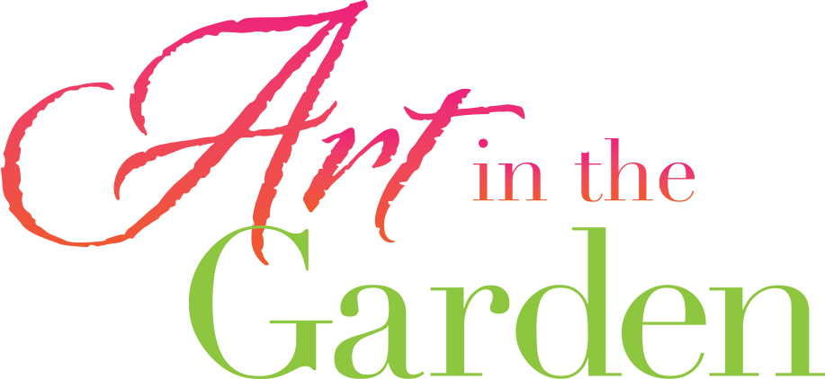

2022 VENDOR
CONFIRMATION AGREEMENT

10’x10’ BUSINESS VENDOR BOOTHS: $150
Larger booths and corner spaces are available for an additional fee. Corner spaces are limited and are first come/first served. Late fee if confirmation agreement received after March 26, 2025: $25

☐ Yes, I am interested in participating in the 2022 Art in the Garden event as a Business Vendor!

Name: _________________________________________________________
Company: _______________________________________________________
Address: _________________________________________________________
Phone: _________________________________________________________
Email Address: ___________________________________________________

Please confirm my reservation for a: _____ 10 x 10 Booth Fee: $150
_____ 10 x 20 Booth Fee: $250
_____ Corner Booth Fee: $50 Additional

Please charge my credit card:
Credit Card #: ____________________________________________________
Exp. Date: ______(mo.) _____(yr.) CVV: ___________________________
Name on Card: ___________________________________________________

Signed:_________________________________ Date:__________________
- Payment can also be made by check or via phone at 602-262-4727.
- All fees benefit the non-profit Shemer Art Center and help us continue our efforts to support and showcase Arizona artists, and provide visual arts educational programming, exhibitions and events for all residents of and visitors to Arizona.

A summary of the booth set-up I am planning includes:

How did you hear about our event? ___________________________________________________________

Please read carefully the following information to confirm the details of your participation in this event:

- Your booth fee of $150 is due by March 25, 2022. Payments can be made online, via check or in person. Once received, your booth will be confirmed and a 10'x10' white tent and one (1) chair will be set up for you.
- Booth assignments will be made prior to the event and available upon check-in that morning.
- Set up will begin at 7 a.m. with all booths to be ready for guests by 9:45 a.m.
- All vendor vehicles must be moved to our south parking lot by 9:30 am the morning of the event.
- All participating business vendors are asked to stay on-site the entire duration of the event, from 10 a.m. to 4 p.m.

For the event silent auction, we ask you to consider donating one item to raise funds for the Shemer Art Center. For publicity purposes please send us a photo of your donation by April 1, 2022. We would also like a 2-3 sentence description of the item for promotional efforts. Your donation should have a minimum value of $100. Please send this information to us at info@shemerartcenter.org. Thank-you letters will be sent out after the event to recognize your donation for tax purposes. A photo of your silent auction item will be posted at your booth to encourage attendees to enter the raffle.

We will keep you informed about the Art in the Garden event as it gets closer and ask that you also share information about it through your own mailing lists and social media. Together we will ensure this is a great event!

Thank you again for your interest in participating in this event. We look forward to seeing you Saturday & Sunday, April 9 & 10, 2022!

